**multiplexinghistory**

**Multiplexing History**

**A Data Communication Historical Series**

**By Bob Pollard**

**Early Multiplex devices:**

Multiplex systems were originally implemented to use the spare capacity available on a line (circuit) for concurrent character or message transmission. In the early years the distributor or multiplex device, in many cases, was a part of the telegraph equipment. A unit is usually called a distributor if it converted the parallel character bits to a serial bit stream for transmission to the line. The character bits are produced as a group when a key is depressed on the keyboard of the telegraph equipment. This group of bits could not be transmitted in parallel simultaneously on a single line; therefore, it is necessary to convert the bit groups to a serial stream, which is the function of a distributor unit.

The distributor unit could also be designed to handle more than one connected telegraph device. The distributor then becomes a multiplex device since it is connecting more than one telegraph machine to a single line.

**Note**: (1930s -1980s) The term ‘transmitter-distributor’ (TD) normally identifies a punched paper tape transmitter. The transmitter part reads the holes (bits) in the tape all at the same time (parallel) and the distributor part transmits the bits to the line in a serial manner.

**Quadruplexing (1800s):**

Duplex operation was very often used (two-way simultaneous operation), since the capacity of a busy line was practically doubled by the addition of operators and the installation of a little apparatus at the terminals and no change in the line. By 1872 duplex operation was quite common on Western Union lines. In 1874, Edison showed how to double the capacity of the line again, by using a quadruplexing scheme. This feature allowed the transmission of two independent messages in the same direction at the same time, a method called diplexing. Diplexing was never used by itself, but always in conjunction with quadruplexing. Edison's idea was to send one message (signals) by varying the strength of the signal (off and on period) and the other message by polarity, positive and negative.

There were two sounders or relays, one responding to signal (current) strength, the other to signal polarity. The diplex circuit now only had to be duplex-ed by one of the existing methods, and two messages could be sent in each direction at the same time, or four in all. Soon all the most important lines were using quadruplexed operation. By 1878, Western Union had 13,000 miles of quadruplexed lines. There were four operators at each end, two sending and two receiving, all at the same time if necessary. Edison made many contributions to telegraphy, of which quadruplexing and the stock ticker are the most famous.

There were other multiplexing methods of transmitting more than one message at a time over a single wire, such as a system implemented in 1873 using a commutator or distributor at each end of the line, running synchronously, so that each user (line) was connected for a fixed interval of time on each revolution of the distributor. Today, this is called time-division multiplexing.

**A couple of early Multiplex examples:**

**Delaney Multiplex (ca1882):**

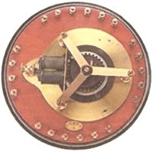

Delaney figured that several operators could use the same wire, one after the other, because of the time gaps left while each operator prepared the next code. This was known as Time Division Multiplex (TDM). This multiplex system mechanism rotated so that each operator’s machine was connected to the line for a short period of time before the connection was passed to the next operator. This multiplex system mechanism rotated so that each operator’s machine was connected to the line for a short period of time before the connection was passed to the next operator.

If everyone maintained their sequential timing and was ready when it was their turn, this multiplexing device would operate at maximum efficiency. Of course, this was not the case, but each connected machine would be picked up by the multiplex unit in a sequential manner even if a machines character was not ready or was waiting for a connection through the multiplex.

**Baudot distributor (ca1894):**

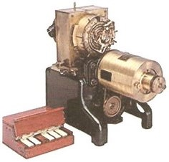

Baudot also invented a 'distributor' system for simultaneous transmission of several messages (multiplexing) on the same telegraphic circuit (line). The characters from the different telegraph machines were transmitted concurrently on the line; Time Division Multiplexing (TDM).

**1900s:**

Thomas Edison’s early quadraplex device was an electrical-mechanical device that divided the line time between more than one telegraph machine, interspersing characters from the different terminals on one line. In 1913 Western Union developed an electrical-mechanical multiplexing device, which allowed the transmission of eight messages, interspersed simultaneously over a single line. Then Varioplex, introduced by Western Union in 1936, allowed 72 terminal transmissions at the same time. Most of the connected terminals operated at very low speeds, which allowed the signals to be combined and carried on high speed lines or voice grade facilities using carrier devices that divided up the facilities using frequency division multiplexing.

**Multiplex devices (1950s – 1980s):**

Multiplexing is a technique for the utilization of a single voice grade channel (line) or any other circuit for multiple terminals. There are many multiplexing schemes, some better than others, that allow many terminals to simultaneously share a circuit (line / channel). For example: A multiplex device could be a digital unit operating within the DC side of the line using Time Division Multiplexing (TDM) or a Frequency division Multiplexer (FDM), which divides up the analog (AC) side of the line. Frequency Division Multiplexing could also be accomplished as described in the ‘Carrier’ page where the voice grade channel was divided up by assigning a different frequency spectrum to each connected terminal (Carrier / MODEM).

A single multiplex device could contain a group of Carriers or MODEM(s), where the terminals are assigned a connection point on the DC side of the Multiplex device, which in turn connects to a common analog line (voice channel). In Time Division Multiplexing the Multiplex device provides a number of connections on the DC side allowing many terminals to be connected to the Multiplex device. Each connected terminal is assigned a time slice and the DC bits / characters (signals) from all the terminals are serially interspersed and transmitted over a voice grade channel, or another type facility, through a high-speed MODEM or some other device. The combined bit per second (bps) rate of all the terminals determines the total number of terminals that can be connected to the TDM since the main line (analog voice channel or other facility) will have to handle the combined bps rates of all the terminals. Also, a TDM device must be attached to the receiving end of the line, which will de-multiplex (separate) the data bit stream (signal). The TDM device allows a higher bps transmission rate when compared to FDM.

Multiplexing is different than the process of several terminals sharing one line, which is normally referred to as a multi-drop, multi-point or multi-station line. A shared line, in a controlled environment, requires that the terminal must be selected before sending or receiving can take place. This avoids the problem, in an uncontrolled situation, where all the terminals receive all the data being transmitted on the line. The multi-point connections could be on the DC side of the MODEM or on the AC side of the MODEM (line).

**Frequency Division Multiplexing:**

Figure 1 is an illustration of Frequency Division Multiplexing. With frequency division multiplexing the voice grade channel or other facility, as illustrated in Figure 1, is divided into sub channels (bands), with each sub channel (1, 2, 3 & 4) assigned a different carrier frequency (f-A, f-B, f-C & f-D) that will be modulated to represent the digital data.

**Time Division Multiplexing:**

Figure 2 provides an illustration of Time Division Multiplexing (TDM). When time division multiplexing is used each connected device (terminal) is assigned a time slice by the TDM device and the combined signal is then transmitted through a high-speed MODEM over a voice grade line or any other connecting media. Each time division (slice) can involve (carry) single bits, characters, groups of bits (bytes / blocks) or packets. The **X** enclosed in a box represents a synchronizing bit or character.

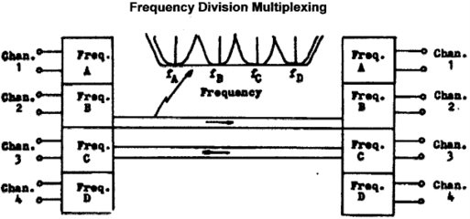

**FIGURE 1**

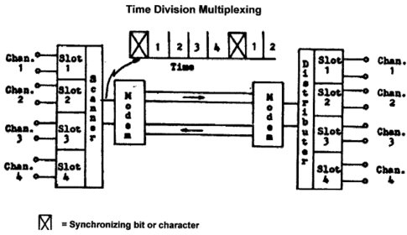

**FIGURE 2**

**Data Structure:**

In the beginning discussions concerning data transmission speeds were expressed in Characters per Minute (CPM). Following that time period CPM and Words per Minute (WPM) were used to indicate data transmissions speeds. Five characters plus a space is used to represent one word.

Then Bits per Second (bps) and Baud rates became the norm for indicating data transmission speeds. Data rate speeds of 1200, 2400, 4800 and 9600 bits per second were considered high speed operation in the mid-1950s, 1960s and 1970s.

In today’s world nearly all data rates are defined through the use of Bits per Second (bps) or Bytes per Second (BPS), which represents eight bits. Bits or Bytes can be grouped into blocks or packets; and they can represent one individual part in multiplexing schemes. A character, a word, a bit, a byte, a block of data or a packet of data can be multiplexed as one individual unit in Time Division Multiplexing. Baud is not included in this grouping because one baud may represent 1 bit in some cases and a group of bits in other cases. A typical packet contains 1,000 or 1,500 bytes.

**Equipment / Devices:**

Equipment or devices also progressed and development over time. First all data transmission was from point A to B over a limited distance due to degradation of the signal. Relays both standard and multiplexing were implemented to relay, and regenerate the signal, and allow two-way duplex transmission and TDM multiplexing. All signaling over the telegraph lines up to this point utilized Direct Current (DC).

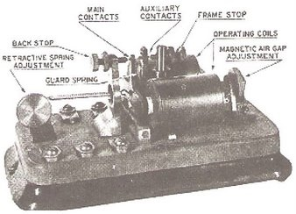

Vacuum tubes were the next major step in improving data transmission speeds and regeneration of signals.

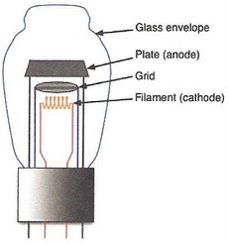

With the implementation of the vacuum tube and carrier systems (1930s) Alternating Current (AC) could be used for transmission of data signals. This also brought Frequency Division Multiplexing (FDM) on-line.

Transistors were used to replace vacuum tubes in most communication equipment starting in the 1960s. They were smaller and produced less heat, and also were more reliable.

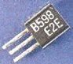

Transistors could be grouped and electrically connected to form a ‘chip’. Examples: below (left), a multiple transistor chip. Below (right) a two transistor “AND’ gate.

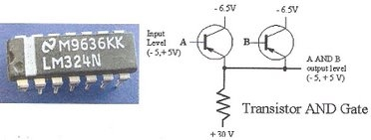

Then transistors, chips and other electronic units can be placed on an integrated circuit card or board, which is basically what we have today.

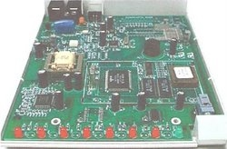

**Transmission lines / conductors:**

In the beginning after experimenting with various metals including soft copper (which easily broke), the conductors used for connection purposes between various sending and receiving points used iron and steel, with galvanized solid wire being one of the best. This was followed by an improved stronger copper wire, which became the connecting choice for many years, both overhead and underground, until fiber optic came along.

Fiber optic cable is gradually replacing all other land-based conductors, overhead or underground. It provides tremendous high-speed data rates, much greater that copper because it involves the use of a light beam, which can be turned on and off. The speed of light in vacuum is exactly 299,792,458 mps. (meters per second), but normally the speed of light is rounded to 300 000 kilometers per second or 186 000 miles per second.

When not in a vacuum the speed of light depends on the material that the light moves through; for example: light moves slower in water, metal, glass and through the atmosphere. Shine a light beam down a straight hallway, since light travels in a straight line it’s not a problem. If the hallway has a bend (corner) it would be necessary to place a mirror at the bend in order to reflect the light beam around the bend. If the hallway has multiple bends it would be necessary to use multiple mirrors in order to continue angling the beam; the beam bounces from side-to-side all along the hallway. This is basically what happens in an optical fiber cable:

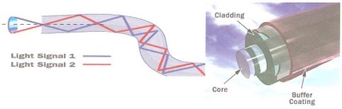

The light in a Fiber-Optic cable travels through the core by constantly bouncing from the cladding (mirror-lined walls); a principle called ‘total internal reflection’. Because the cladding does not absorb any light the light wave can travel great distances. However, some of the light signal degrades, mostly due to impurities in the glass. The extent that the signal degrades over the distance traveled depends on the purity of the glass and the wavelength of the transmitted light.

A Fiber-Optic system may span a few hundred feet or a few thousand miles. Since distance has a direct impact on signal quality it is necessary to implement what is called ‘Fiber Optic relay systems’ (signal regenerators).

The Fiber-Optic relay systems consist of the following:

• Transmitter: Produces and encodes the light signals

• Optical fiber: Conducts the transmitted light signals over a predetermined distance

• Optical regenerator: Necessary to boost the light signals; placed at predetermined intervals on long distance circuits.

• Optical receiver: Receives and decodes the light signals.